H.T No
Regulations:
A17

Sreenidhi Institute of Science and Technology
(An Autonomous Institution)
Code No: 6B730 Date: 12-Jan-2023 (FN)

B.Tech IV-Year I- Semester External Examination, January-2023 (Supplementary)
FINITE ELEMENT METHOD (ME)

Time: 3 Hours Max.Marks:75
Note: a) No additional answer sheets will be provided.
b) All sub-parts of a question must be answered at one place only, otherwise it will not be valued.
c) Missing data can be assumed suitably.

Bloom's Cognitive Levels of Learning (BCLL)

Remember | L1 | Apply | L3 | Evaluate | L5
Understand | L2 | Analyze | L4 | Create | L6

Part - A Max.Marks:25

Answer all QUESTIONS.
 |  | BCLL | CO(s) | Marks
1 | What are the different coordinate systems available? | L2 | CO1 | [2M]
2 | Mention the stiffness matrix for truss element. | L1 | CO2 | [2M]
3 | Write short notes on CST and LST elements. | L2 | CO3 | [2M]
4 | Elaborate on iso-parametric formulation? | L2 | CO4 | [2M]
5 | Find the temperature in an element at 25cm from the origin when the temperature is linearly varying from node 1 at 90 °C to node 2 at 120 °C. Assume node 1 is at origin and total length is 45cm. | L2 | CO5 | [2M]
6 | Mention lumped mass matrix and consistent mass matrix for bar element. | L2 | CO6 | [3M]
7 | What are the different applications of FEM? | L3 | CO1 | [3M]
8 | Write short notes on axisymmetric formulation. | L2 | CO3 | [3M]
9 | Mention the thermal stiffness matrix for one dimensional heat conduction with end surface convection. | L2 | CO5 | [3M]
10 | Name few commercial FEM software packages. | L1 | CO6 | [3M]

Part – B Max.Marks:50
ANSWER ANY FIVE QUESTIONS. EACH QUESTION CARRIES 10 MARKS.

 |  |  | BCLL | CO(s) | Marks
11. | a) | If a displacement field is described as follows;  Determine the strain components ε_{x}, ε_{y} and γ_{xy} at the point x = 1 and y = 0. | L3 | CO1 | [5M]
 | b) | What are the advantages, disadvantages and applications of FEM? | L2 | CO1 | [5M]
12. |  | Determine the nodal displacements, element stress and support reactions in the truss structure shown below, assuming 1 and 3 are fixed. Use E=70GPa and A=200mm².  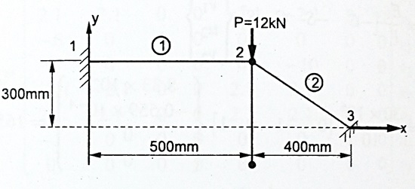 | L3 | CO2 | [10M]
13. |  | Evaluate the element stiffness matrix for a CST element with nodal coordinates; X₁ = 1, X₂ = 5, X₃ = 3 & Y₁ = 2, Y₂ = 4, Y₃ = 6. Assume plane stress condition, E = 200 GPa, µ = 0.25 and thickness = 4mm. | L3 | CO3 | [10M]
14. | a) | Find the integral I = using Gaussian Quadrature method. | L3 | CO4 | [5M]
 | b) | Briefly explain the concept of numerical integration. | L2 | CO4 | [5M]
15. |  | A wall of 0.5m thickness has thermal conductivity of 6 W/mK. The wall is insulated with a material of thickness 0.1m having an average thermal conductivity of 0.3 W/mK. The inner surface temperature is 1200º C and the outside of the insulation is exposed to atmospheric air at 30º C with heat transfer coefficient of 40 W/m²K. Calculate the nodal temperatures.  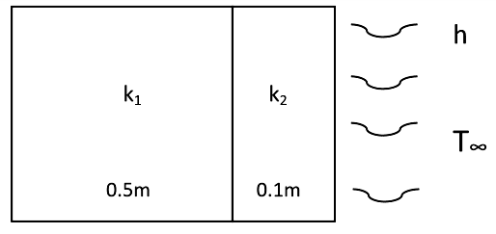 | L4 | CO5 | [10M]
16. |  | Evaluate natural frequencies for the stepped bar shown in axial vibration. Take E = 200GPa, Density = 7850 kg/m³. Take A_{l} = 400 mm² and A₂ = 200 mm².  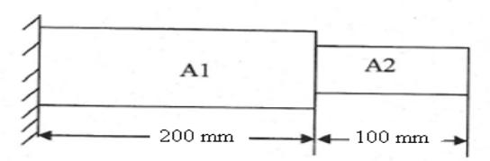 | L4 | CO6 | [10M]
17. | a) | Mention the material matrices for plane stress and plane strain conditions. | L2 | CO1 | [4M]
 | b) | Write the Hermite shape functions of a beam element. | L1 | CO2 | [3M]
 | c) | Mention the shape functions of linear triangular element. | L1 | CO3 | [3M]
18. | a) | Write short note on few 3-D elements available in FEM. | L2 | CO4 | [4M]
 | b) | Derive the thermal stiffness matrix for 1-D bar element under steady state pure heat conduction. | L3 | CO5 | [3M]
 | c) | Write a short note on Dynamic Analysis and its applications in engineering problems. | L3 | CO6 | [3M]

-- 00 -- 00 –

